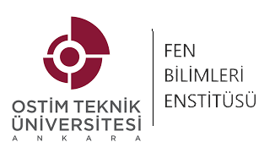
Form FBE 10
OSTİM TECHNICAL UNIVERSITY
INSTITUTE OF NATURAL AND APPLIED SCIENCES

FOREIGN STUDENTS
RESIDENCE INFORMATION FORM
......../......../20.....
I- STUDENT'S CREDENTIALS
Name & Surname
Father's Name
Mother's Name
Place & Date of Birth
Nationality
Passport Number
Foreign National Identity No
Residence Permit Number
Date of Last Arrival in Turkey
Home Address in Ankara
Marital Status

II- ACADEMIC KNOWLEDGE OF THE STUDENT
 | University Name | OSTİM TECHNICAL UNIVERSITY
 | Institute | Institute of Natural and Applied Sciences
 | Department
 | Student No
 | Program/Term
 | Program Enrollment Date
 | Possible Date of graduation

Name-Surname Signature
Student

III- ACADEMIC STATUS OF THE STUDENT OVER THE YEARS

(To be filled in by Student Affairs)

IV- PERIODS OF STUDY
Normal education period in graduate scientific preparation programs is 1 semester and maximum 2 semesters (1 year).
The maximum duration of education in graduate programs is 6 semesters (3 years)
The maximum duration of education in doctoral programs is 12 semesters (6 years).
Asst. Prof. Hikmet BAL
Director of the Institute
Description:
OSTİM Teknik Üniversitesi OSTİM, 06374 Ankara / Türkiye
Telefon No.: (0 312) 386 10 92 Belgegeçer : (0 312) 354 39 93
E-mail: info@ostimteknik.edu.tr

